Buy Credits

IF YOU WANT TO CHANGE THE CURRENT CREDITS INFORMATION

- Go to backend, enter the username and password
- Go to System → Custom Variables

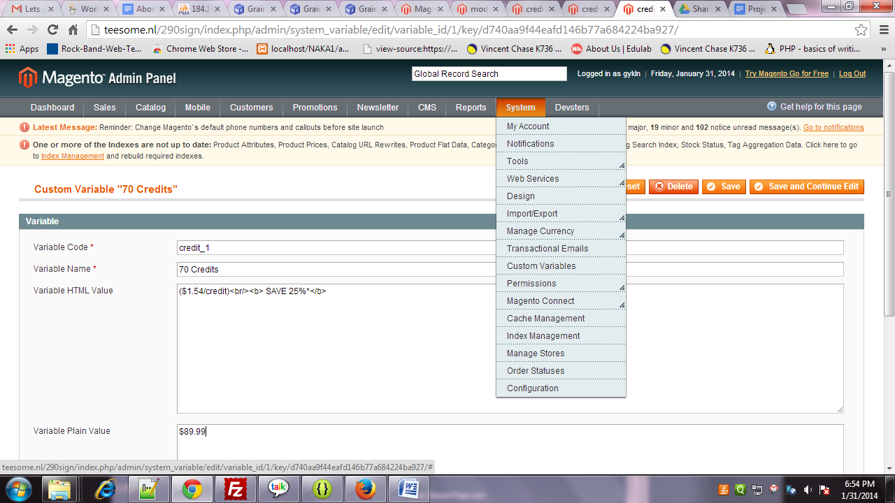

Click on the Custom Variable.

- Click on Credit_1 link to get information.

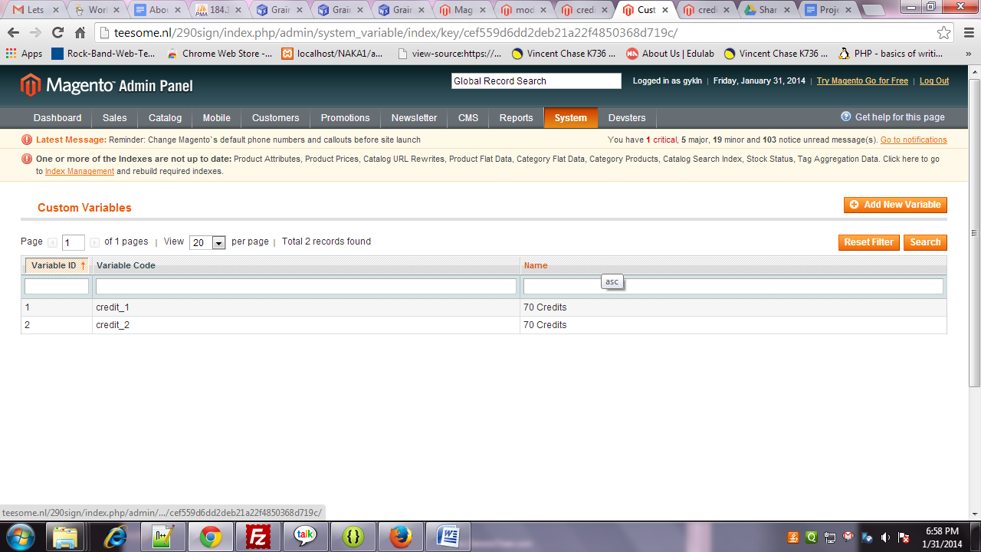

- Click on any value. This will open information of that variable. Where you can change things.

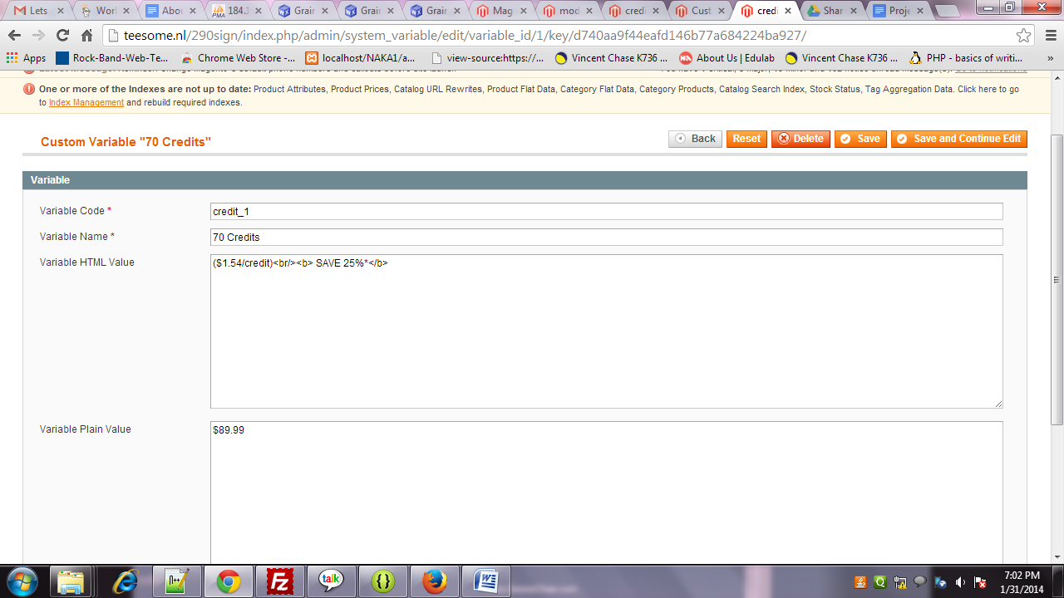

- Click on the save button.

HOW TO ADD NEW OPTION TO SHOW ON BUT CREDITS PAGE

- Go to SYSTEM -> custom variables
- This page will open.

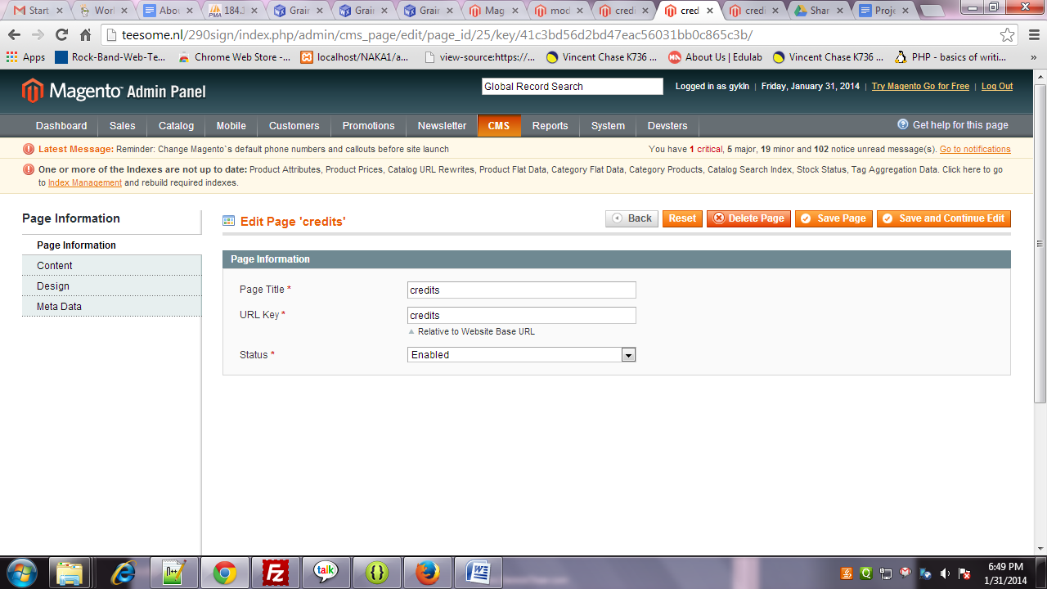

Click on Content tab.

- This page will open.

Click on the Add new variables

- Enter the variable code and other required information.

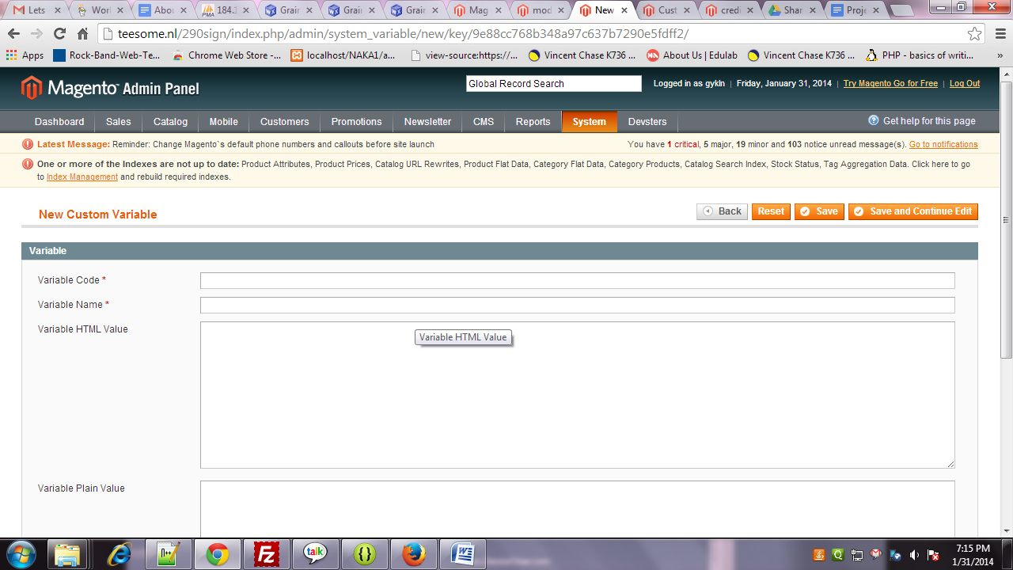

After adding the information Click on the save button.

- The go to cms->pages.
- Search for credits page.
- Open it and go content section.
- This page will open.

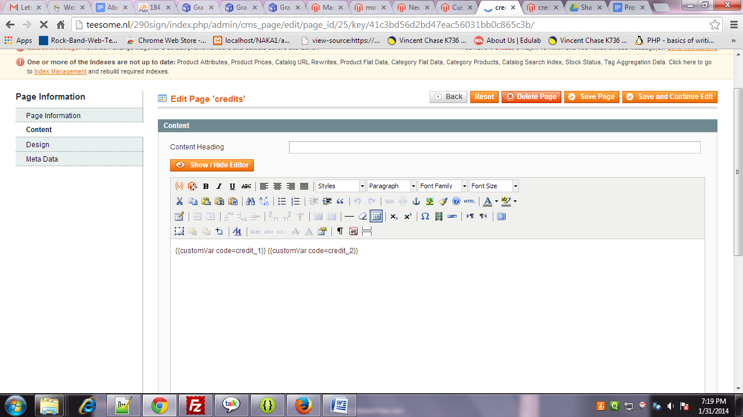

- Add this {{customVar code= here your custom variable code you given }}
- Save it and its done.

